NIP Project — Submission Template
Pega Platform project · This document is your complete submission
Read this before you start:
1. Fill in Section 1 completely. The Pega application name must follow the format NIP-[Project]-[YourName].
2. Create a new Operator in Pega with your full name and log in as that operator before taking any screenshot.
3. When you create your test case, enter YOUR FULL NAME in the Issue Description (Vehicle) or Movie Name (Movie) field.
4. Complete only the section for your chosen project. Delete the other project section.
5. Paste one screenshot per user story (10 total). Follow the screenshot rules in your selected project section.
6. Answer every question in Sections 3 and 4 in your own words.
7. Save the file using this format: ProjectName_FirstName_LastName.docx. Use VehicleService or MovieTicket as the ProjectName. Examples: VehicleService_Ravi_Kumar.docx or MovieTicket_Ravi_Kumar.docx.

Section 1 — Your Details
Full Name | Arvapalli Mohan pavan kumar
Email ID (registered on NIP) | 23jr1a1234@kitsguntur.ac.in
Phone Number | 7993279628
College Name | KKR & KSR Inistution Of Technology & Sciences
Course (e.g. IT, CS) | IT
State | Andhra Pradesh
Project Chosen (Vehicle Service OR Movie Ticket Booking) | Movie Ticket Booking
Pega Application Name (e.g. NIP-VehicleService-YourName) | NIP-Movie Ticket Booking-mohan
Case Type Name (exact) | Ticket Booking
Pega Instance URL | https://qnocecqm.pegaacademy.net/prweb/app/nip--movie-ticket--mohan/9s5UaqMnbUJFF2eeddrCytdKBQmZzvBO*/!STANDARD?pzuiactionzzz=CXtycX04MmEwYWU4NDMyNjYzOGZjOTBiZmU3N2YzMWVmOTRkODZlMzhlOWI5NjYxNDcwNTE3NjVjNmIxMzgyYWNmM2Y0ZTAzNjNhY2JkYjJkYjZkZjQ3ZTdmM2IzNGU5YTQ0NmE=*
Operator Name (created in Pega with your full name) | arvapallimohan@MT

Section 2A — Sumbit Movie Ticket Request
Complete this section only if you selected this project. Delete the other project section before submitting.

Screenshot rules — IMPORTANT before you start:
1. Name your Pega application as: NIP-VehicleService-YourName OR NIP-MovieTicket-YourName
2. Create a new Operator in Pega with your full name (Security → Operators) and log in as that operator.
3. When you create your test case, enter YOUR FULL NAME in the Issue Description (Vehicle) or Movie Name (Movie) field.
4. The logged-in operator name must be visible in every screenshot wherever the Pega interface displays it.
5. The student's full name must be visible in all running-case screenshots.
6. Configuration screenshots must clearly show the relevant application or rule name.
Screenshots that do not show these will not be accepted.

US-001 — Submit Vehicle Service Request
What is expected:
Case created, customer submits Vehicle ID, Vehicle Model, Issue Description. Validati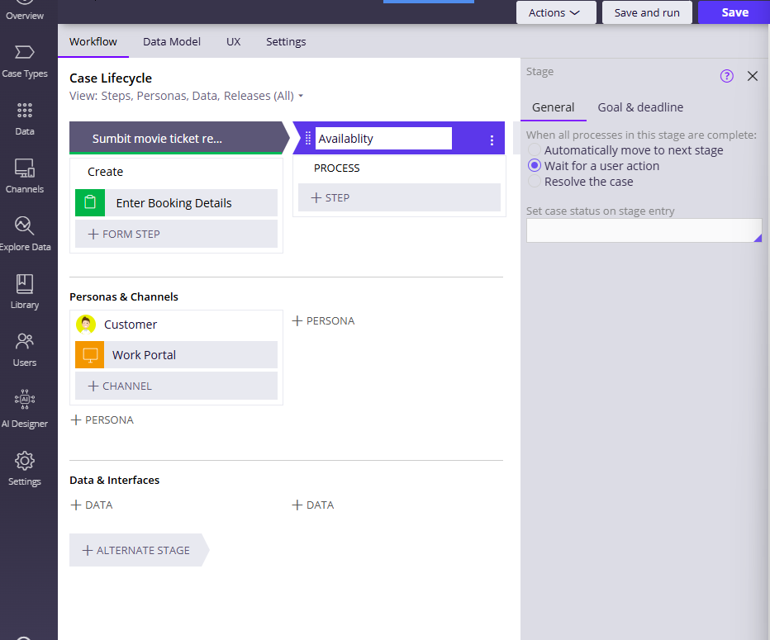
on applied.
Screenshot — paste your screenshot below this line:
[ Paste screenshot here - follow the screenshot rules above ]

What I built for this (1–2 lines in your own words):
First I created the intial stage suubmiting the booking details & next add a reaming steps like the enter booking details & next customer name

US-002 — Perform Vehicle Inspection
What is expected:
Inspection stage with Service Advisor step. Inspection Notes and Condition Rating captured.
Screenshot — paste your screenshot below this line:
[ Paste screenshot here - follow the screenshot rules above ]
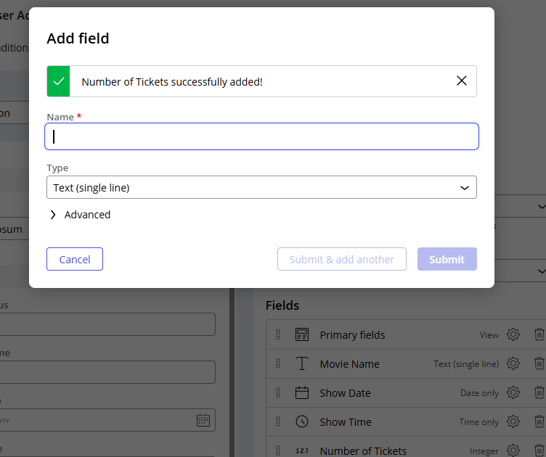

What I built for this (1–2 lines in your own words):
[ Type here ]
I have added options to the fields by using submting & the add anoter it will helps us to add new lines & lastly submit

US-003 — Generate Service Estimate
What is expected:
Labor Cost and Parts Cost captured. Total Cost calculated automatically by declare expression.
Screenshot — paste your screenshot below this line:
[ Paste screenshot here - follow the screenshot rules above ]
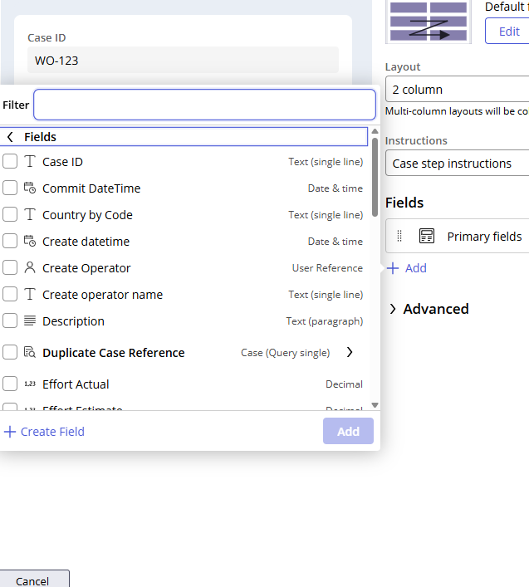

What I built for this (1–2 lines in your own words):
[ Type here ] if the files are available here ok If not created a filed option selcet

US-004 — Approve Service Estimate
What is expected:
Approval stage assigned to Customer. Approval Status captured. Flow branches on approve/reject.
Screenshot — paste your screenshot below this line:
[ Paste screenshot here - follow the screenshot rules above ]
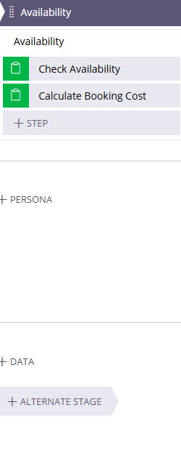

What I built for this (1–2 lines in your own words):
[ Type here ]
After that I added availblty session In that check availblity & clacuationg booking cost

US-005 — Maintain Vehicle Data
What is expected:
Reusable Vehicle data object created with Vehicle ID, Model, Type — linked to case.
Screenshot — paste your screenshot below this line:
[ Paste screenshot here - follow the screenshot rules above ]

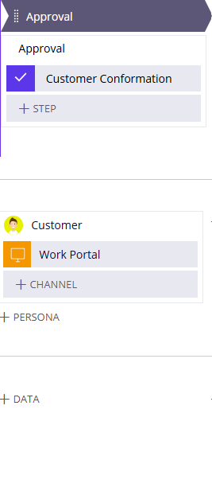

What I built for this (1–2 lines in your own words):
[ Type here ]
After that I created approval for ticketing in online approval

US-006 — Review Service Estimate
What is expected:
Approval screen shows Labor Cost, Parts Cost and Total Cost clearly to the Customer persona.
Screenshot — paste your screenshot below this line:
[ Paste screenshot here - follow the screenshot rules above ]
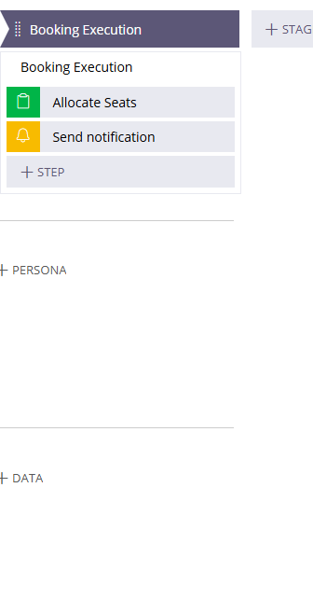

What I built for this (1–2 lines in your own words):
[ Type here ]
This is the last of the my entire application like booking excution

US-007 — Auto Assign Technician
What is expected:
Service Execution stage with routing to HeavyVehicleQueue or LightVehicleQueue. Assigned Technician and Service Status properties maintained.
Screenshot — paste your screenshot below this line:
[ Paste screenshot here - follow the screenshot rules above ]

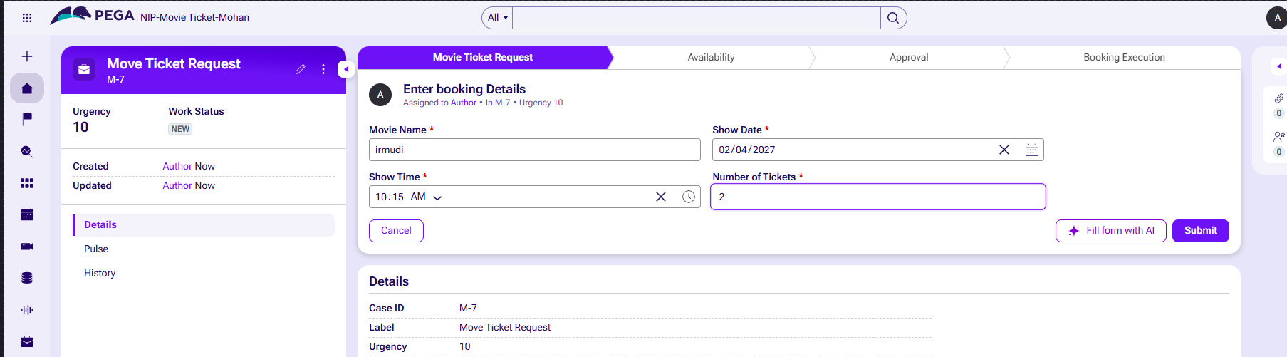

What I built for this (1–2 lines in your own words):
[ Type here ]
Here giving the details for move booking

US-008 — Notify Service Completion
What is expected:
Correspondence rule created and triggered on case resolution. Email includes case and vehicle details.
Screenshot — paste your screenshot below this line:
[ Paste screenshot here - follow the screenshot rules above ]
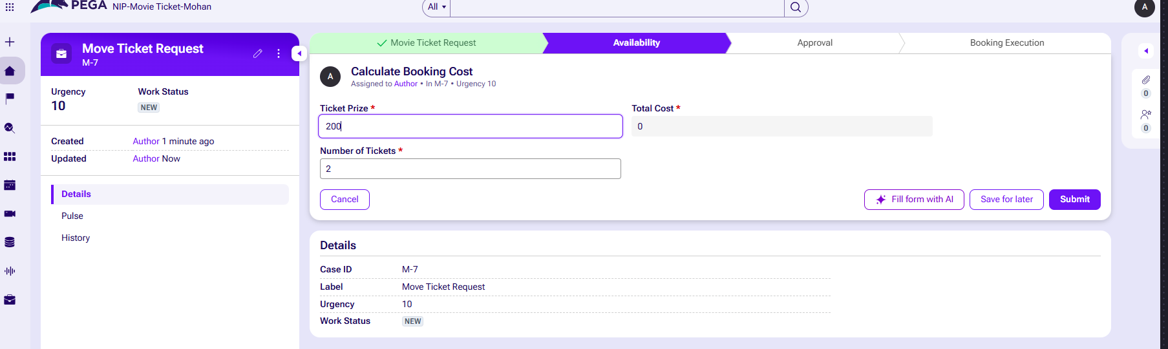

What I built for this (1–2 lines in your own words):
[ Type here ]
After that creation of availblty like ticket cost,total sets,no of tickets

US-009 — Define Service SLA
What is expected:
SLA configured on the case type. Goal: 2 days. Deadline: 3 days. Priority increases on breach.
Screenshot — paste your screenshot below this line:
[ Paste screens 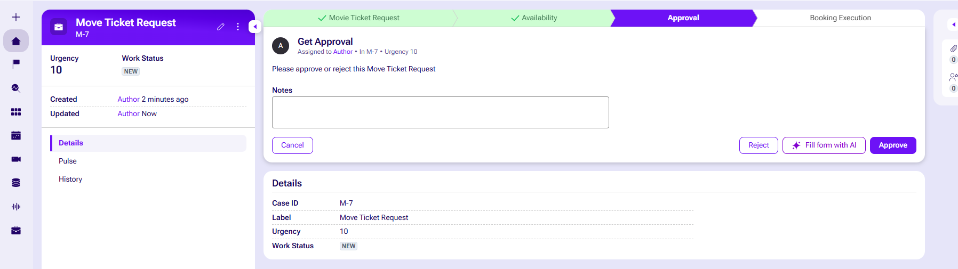hot here - follow the screenshot rules above ]

What I built for this (1–2 lines in your own words):
[ Type here ]
Giving approval like accept or reject

US-010 — Route by Vehicle Type
What is expected:
Routing rule or Decision Table routes to HeavyVehicleQueue or LightVehicleQueue based on Vehicle Type property.
Screenshot — paste your screenshot below this line:
[ Paste screenshot here - follow the screenshot rules above ]

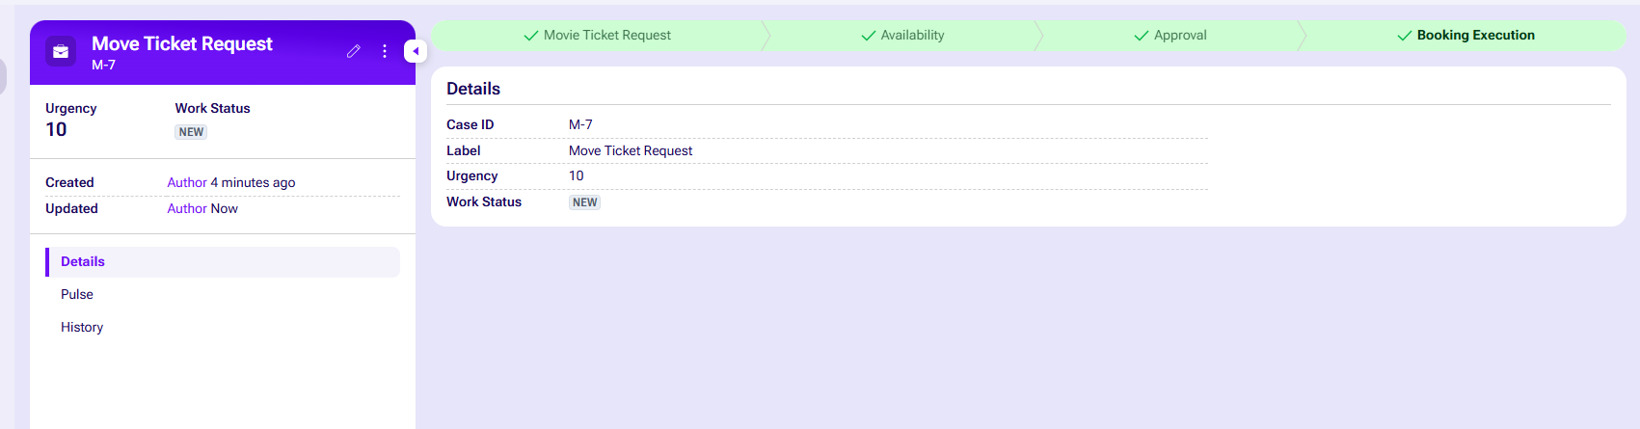

What I built for this (1–2 lines in your own words):
[ Type here ]
All details of movie

Section 2B — Movie Ticket Booking Management Application
Complete this section only if you selected this project. Delete the other project section before submitting.

Screenshot rules — IMPORTANT before you start:
1. Name your Pega application as: NIP-VehicleService-YourName OR NIP-MovieTicket-YourName
2. Create a new Operator in Pega with your full name (Security → Operators) and log in as that operator.
3. When you create your test case, enter YOUR FULL NAME in the Issue Description (Vehicle) or Movie Name (Movie) field.
4. The logged-in operator name must be visible in every screenshot wherever the Pega interface displays it.
5. The student's full name must be visible in all running-case screenshots.
6. Configuration screenshots must clearly show the relevant application or rule name.
Screenshots that do not show these will not be accepted.

US-001 — Submit Movie Ticket Request
What is expected:
Case created, customer submits Movie Name, Show Date, Show Time, Number of Tickets. Validation applied.
Screenshot — paste your screenshot below this line:
[ Paste screenshot here - follow the screenshot rules above ]

What I built for this (1–2 lines in your own words):
[ Type here ]

US-002 — Check Show Availability
What is expected:
Availability stage. Seat Availability Status and Available Seats Count captured. Booking proceeds only if available.
Screenshot — paste your screenshot below this line:
[ Paste screenshot here - follow the screenshot rules above ]

What I built for this (1–2 lines in your own words):
[ Type here ]

US-003 — Calculate Booking Cost
What is expected:
Total Cost calculated automatically from Ticket Price and Number of Tickets using a business rule.
Screenshot — paste your screenshot below this line:
[ Paste screenshot here - follow the screenshot rules above ]

What I built for this (1–2 lines in your own words):
[ Type here ]

US-004 — Confirm Booking Request
What is expected:
Approval stage assigned to Customer. Booking Status captured. Flow branches on confirm/cancel.
Screenshot — paste your screenshot below this line:
[ Paste screenshot here - follow the screenshot rules above ]

What I built for this (1–2 lines in your own words):
[ Type here ]

US-005 — Maintain Movie and Show Data
What is expected:
Reusable Movie and Show data objects created with Movie Name, Genre, Show Date, Show Time, Seat Capacity — linked to case.
Screenshot — paste your screenshot below this line:
[ Paste screenshot here - follow the screenshot rules above ]

What I built for this (1–2 lines in your own words):
[ Type here ]

US-006 — Review Booking Details
What is expected:
Confirmation screen shows Movie Name, Show Timing, Number of Tickets and Total Cost clearly.
Screenshot — paste your screenshot below this line:
[ Paste screenshot here - follow the screenshot rules above ]

What I built for this (1–2 lines in your own words):
[ Type here ]

US-007 — Process Ticket Booking
What is expected:
Booking Execution stage. Seat Numbers, Ticket ID and Booking Confirmation Status maintained.
Screenshot — paste your screenshot below this line:
[ Paste screenshot here - follow the screenshot rules above ]

What I built for this (1–2 lines in your own words):
[ Type here ]

US-008 — Notify Booking Confirmation
What is expected:
Correspondence rule triggered on case resolution. Email includes movie, show, seat and cost details.
Screenshot — paste your screenshot below this line:
[ Paste screenshot here - follow the screenshot rules above ]

What I built for this (1–2 lines in your own words):
[ Type here ]

US-009 — Define Booking SLA
What is expected:
SLA configured on the case type. Goal: 1 day. Deadline: 2 days. Priority increases on breach.
Screenshot — paste your screenshot below this line:
[ Paste screenshot here - follow the screenshot rules above ]

What I built for this (1–2 lines in your own words):
[ Type here ]

US-010 — Route by Show Type
What is expected:
Routing rule or Decision Table routes to PremiumShowQueue or StandardShowQueue based on Show Type property.
Screenshot — paste your screenshot below this line:
[ Paste screenshot here - follow the screenshot rules above ]

What I built for this (1–2 lines in your own words):
[ Type here ]

Section 3 — About Your Application
These answers are checked against your screenshots. Write exactly what is in your application.

Q1. List your stages in the order they appear in your case lifecycle.
Stage names in order, separated by commas.
[ Type here ]
Movie search,intial stage,availbilty stage,approval stage,booking excution

Q2. Name the data object(s) you created and the properties inside them.
Data object name and its properties.
[ Type here ]
Movie(mmoviename,Genere)
Show(show time,show date,Seat capaclty)

Q3. What is the exact name and type of the rule you used to calculate Total Cost?
Provide:
• Rule Name
• Rule Type
• Properties used in the calculation
• Formula used
[ Type here
Rule Name : Total cost
Rule Type : Currency
Properties used in the calculation : TicketPrice and NumberofTickets
Formula Used : .TotalCost = .TicketPrice*.NumberofTickets

Section 4 — Your Understanding
Short, honest and specific answers score well.

Q4. What did Blueprint generate for you, and what did you add or change yourself afterwards?
Be specific about what was already there and what you built or modified on top.
[ Type here ]

First we launch the Pega instance in the Business Architecture.
Next I login into the instance by using the login credientials provided by the pega.
Next, I select the new application and create the Blueprint by using the create blueprint option.
Next, I select the others option to the application creation in blueprint.
And next, I type the application name and description and location and language.
Next , I create the case types and add the data to the case types.
Next, I enter the data in the fields and run the cases in the blueprint.
Next, I after completion of blueprint I download the blueprint
And I add the blueprint and open the app studio.
In the app studio, I created the stages and the fields as followed by the given usecases.
By following the above process steps I completed the all usecases and project too.

Q5. Was there anything Blueprint created that you had to correct or configure further? Describe one example.
A real example from your own work.
[ Type here ]

Yes, Blueprint created only basic fields and flow, but I had to correct many things. One example is TotalCost calculation. Blueprint did not have any calculation for TotalCost, it was just a field. I had to create a Declare Expression rule CalculateTotalCost to calculate TotalCost = NumberOfTickets * TicketPrice. Also Blueprint routing was directly to workbasket, I corrected it and configured Decision Table DetermineShowQueue to route Premium shows to PremiumShowQueue and Standard shows to StandardShowQueue.

Q6. Explain your case flow from creation to resolution, in order.
What happens first, who does what, when the case closes.
My case flow from creation to resolution is:
1. Creation - Customer creates Movie Ticket Request and enters Movie Name, Show Time, Number of Tickets.
2. Availability Check - System checks seat availability.
3. Approval Stage - Request goes to Customer for confirmation with Confirm/Cancel option.
4. Booking Execution - If confirmed, system calculates TotalCost, generates TicketID and SeatNumbers, and routes to PremiumShowQueue or StandardShowQueue based on Show Type using Decision Table.
5. Resolution - Booking Confirmation Status is updated to Confirmed and case is resolved/closed after sending confirmation.

Q7. Pick two design choices you made in your application and explain why you made them.
For each design choice, provide:
• What you implemented
• Why you chose that approach
• What benefit it provides to the application
[ Type here ]
Design Choice 1: Routing with a Decision Table We used a Decision Table to route movie tickets automatically. It reads the "Show Type" property from the intake form. The system sends cases to PremiumShowQueue or StandardShowQueue. This keeps our system flexible and easy to update later.

Design Choice 2: Customer Approval Screen We added a customer confirmation screen right after checking seat availability. Users must select confirm or cancel before final processing. This choice saves system resources. It prevents unnecessary price calculations and seat locking for abandoned bookings.

Q8. What was the hardest part, and how exactly did you fix it?
Specific and honest. A real challenge scores much better than a generic answer.
[ Type here ]
The hardest part for me was configuring the TotalCost calculation and routing logic. Initially my Declare Expression CalculateTotalCost was not firing and TotalCost was showing 0 because I set wrong context and target property was not . TotalCost. Also my Decision Table Determine ShowQueue was not routing correctly because I used wrong property ShowTime instead of ShowType.
How I fixed it: I checked App Studio logs and traced the rule. I corrected the Declare Expression to set Target as . TotalCost and changed Source to . NumberOfTickets * .TicketPrice. For Decision Table, I changed condition to use ShowType property and tested with two cases one Premium and one Standard, then it routed correctly to PremiumShowQueue and StandardShowQueue. I also revalidated Data Object Movie Ticket Request properties.

Q9. If the approval step was only needed when Total Cost is above a certain amount, what would you change in your application?
Explain what you would change and where. You do not need to build this.
[ Type here ]

If approval is needed only when Total Cost is above a certain amount, I would change the Case Flow.
What to change: I will create a When rule named Is High Value Booking with condition . TotalCost > 1000. Then in the main flow, before Approval Stage, I will add a Decision shape. If .TotalCost > 1000 is true, it will go to Approval Stage with Confirm/Cancel. If false, it will skip approval and go directly to Booking Confirmation stage.
Where to change: In Process Flow -> Before Approval Step -> Add Decision and When rule. I can also set the Approval Stage's skip condition to skip when TotalCost is less than or equal to 1000.

Q10. List three exact rule names from your application that you personally created or modified.
Include the rule name and rule type for each one (for example: CalculateTotalCost - Declare Expression).
[ Type here ]

CalculateTotalCost - Declare Expression
DetermineShowQueue - Decision Table
PremiumShowQueue - Work Queue

Q11. List all personas used in your application.
List the persona names exactly as they appear in your application.
[ Type here ]

Booking Agent, Customer

Q12. List all work queues used in your application and explain when each one is used.
For each work queue, provide its exact name and the condition or type of work routed to it.
[ Type here ]
PremiumShowQueue : The PremiumShowQueue handles high-tier bookings that require special tracking or premium validation. Work is automatically routed to this queue.
StandardShowQueue : The StandardShowQueue handles everyday booking cases for the application. Work is automatically routed to this queue when the ticket's show type is a regular standard ticket requests are processed normally.

Before You Submit — Check These
Read through once before uploading.
1. Section 1 filled in. Application named as NIP-[Project]-[YourName]. Names match the actual application.
2. New Operator created in Pega with my full name. I logged in as that operator for all screenshots.
3. Only my chosen project section remains — the other project section is deleted.
4. All 10 user story screenshots are pasted and follow the operator, running-case, application, and rule-name evidence requirements.
5. Every question in Sections 3 and 4, including Q10, Q11, and Q12, is answered in my own words.
6. This file is named using the required format: ProjectName_FirstName_LastName.docx (for example, VehicleService_Ravi_Kumar.docx or MovieTicket_Ravi_Kumar.docx) and uploaded as required.

